VCE Systems Engineering Unit 1

**Folio:** Research Layout

When collecting research material for a project you need to document it correctly. This research could take the form of images, diagrams, text, calculations, etc.

Example of stair navigation

Example;

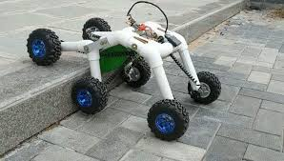

Hinged section so front 4 wheels can move independently of back wheels

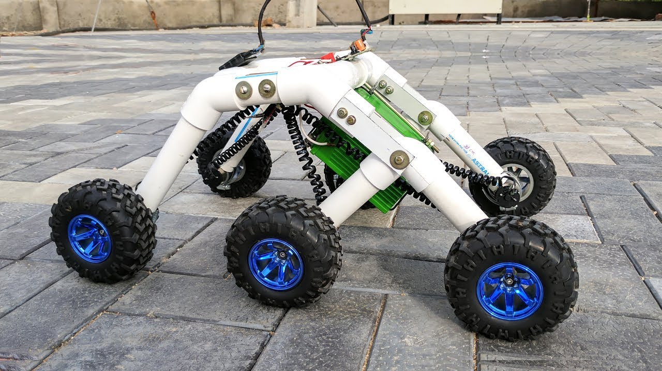

High under carriage clearance to avoid getting caught on terrain.

Use of 6 wheels enables it to better navigate uneven terrain.

Date: 10th Feb 2020

These images come from a youtube video: <https://www.youtube.com/watch?v=3Zx7tGtwF5g>

Use: I like the modular concept of the lightweight but strong PVC pipe, which makes for quick and easy way to construct my project. It could also be easily adjusted and modified, if the parts were not glued permanent together during testing.

Important points

* Research needs to be dated when collected.
* Include the source such as website, book or magazine title or video it was captured from. It is handy to know if you need to go back and get more information from that source.
* Include **annotations** to show what is **important** about the **information gathered** and how this may be **used** in your own project.
* Use of multiple pictures to capture different aspects of the research.